Content Management System

-14BCE008

ABSTRACT

Loonycorn is a startup that has been engaged in delivering technical courses on subjects of Computer Science. It had more than 70 courses in topics of Data Science, Machine Learning and Big Data. However all it courses have been uploaded on 3rd party websites Udemy, StackSocial and Plural. The goal over here was to develop a website for the team so that they wouldn’t have to rely on other websites.

RESOURCES

WIX

Wix.com is a cloud-based web development platform. It allows users to create HTML5 web sites and mobile sites through the use of online drag and drop tools. Users may add functionality such as social plug-ins, e-commerce, contact forms, e-mail marketing, and community forums to their web sites using a variety of Wix-developed and third-party applications.

The website was build with a lot of interrogation and after answering tons of questions as well as search engine optimization from the website side was done.

The link of the website is as follows:

<https://14bce008.wixsite.com/website-1>

SCREENSHOTS

HOMEPAGE

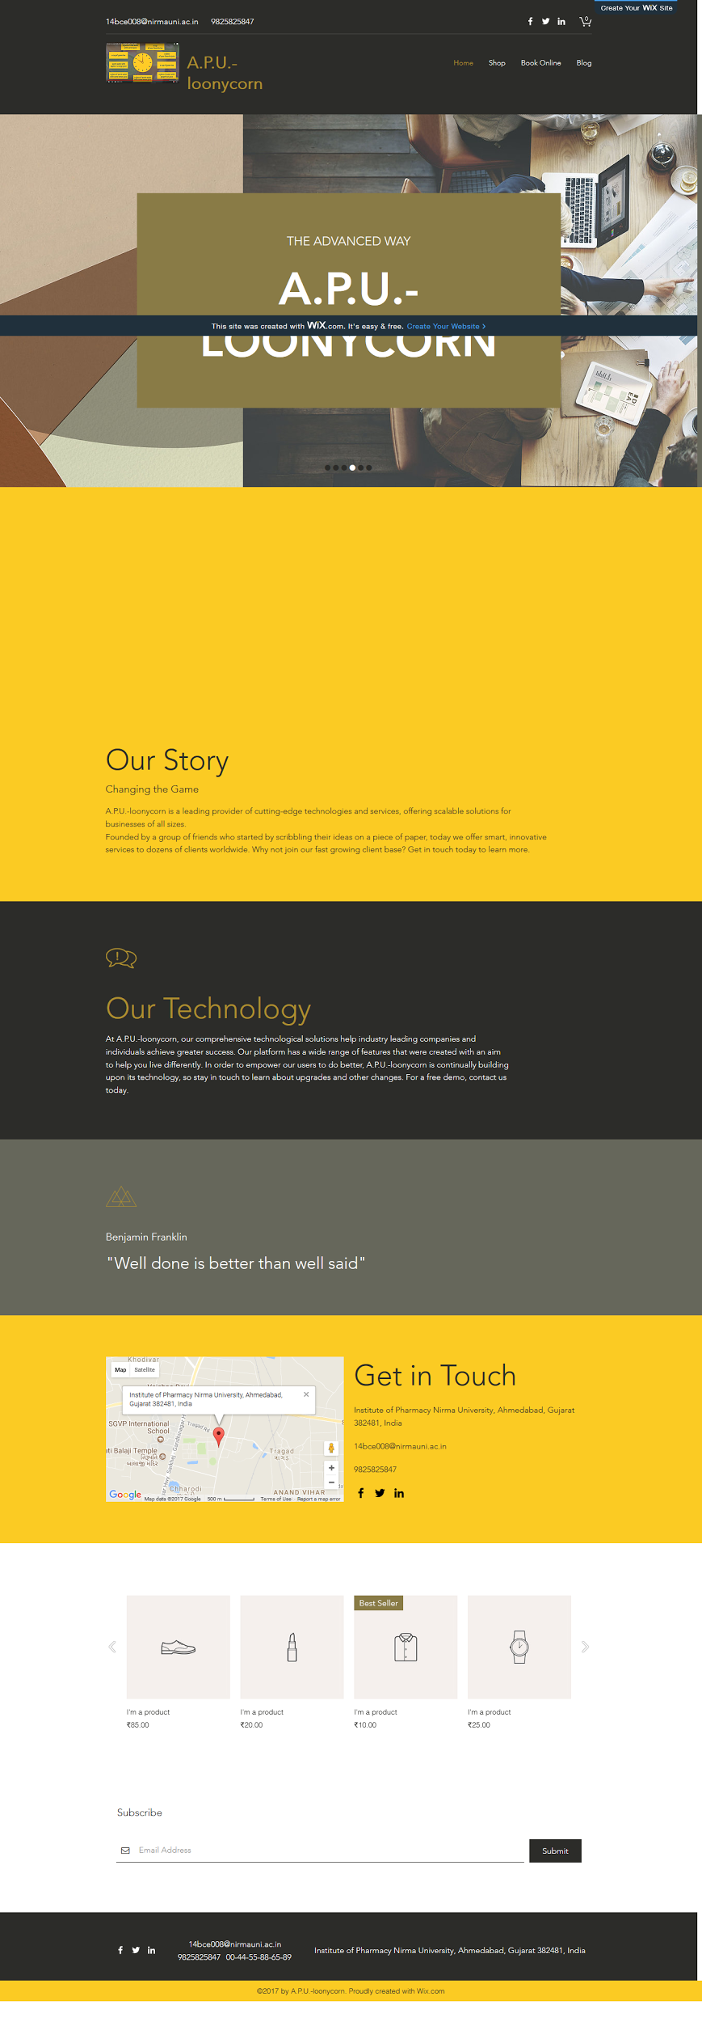

ARTICLES ASSOCIATED WITH THE WEB PAGE

ITEMS AVAILABLE

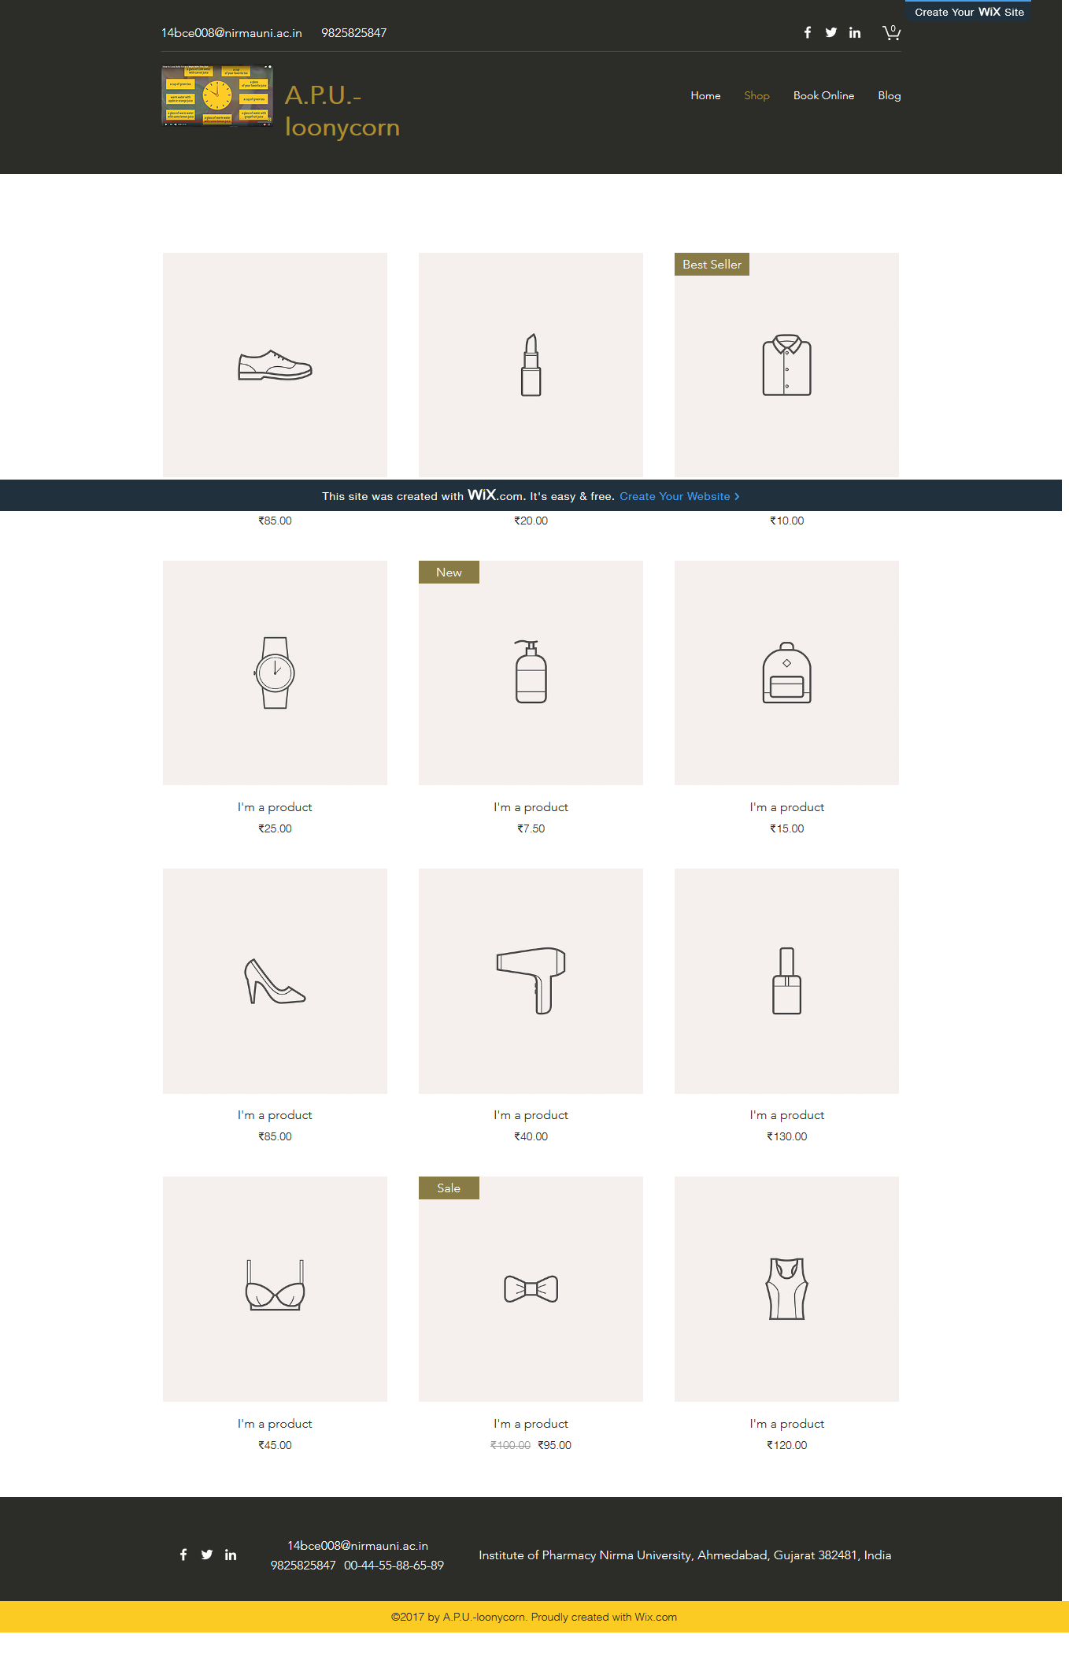

PAGE FOR PURCHASING AN ITEM

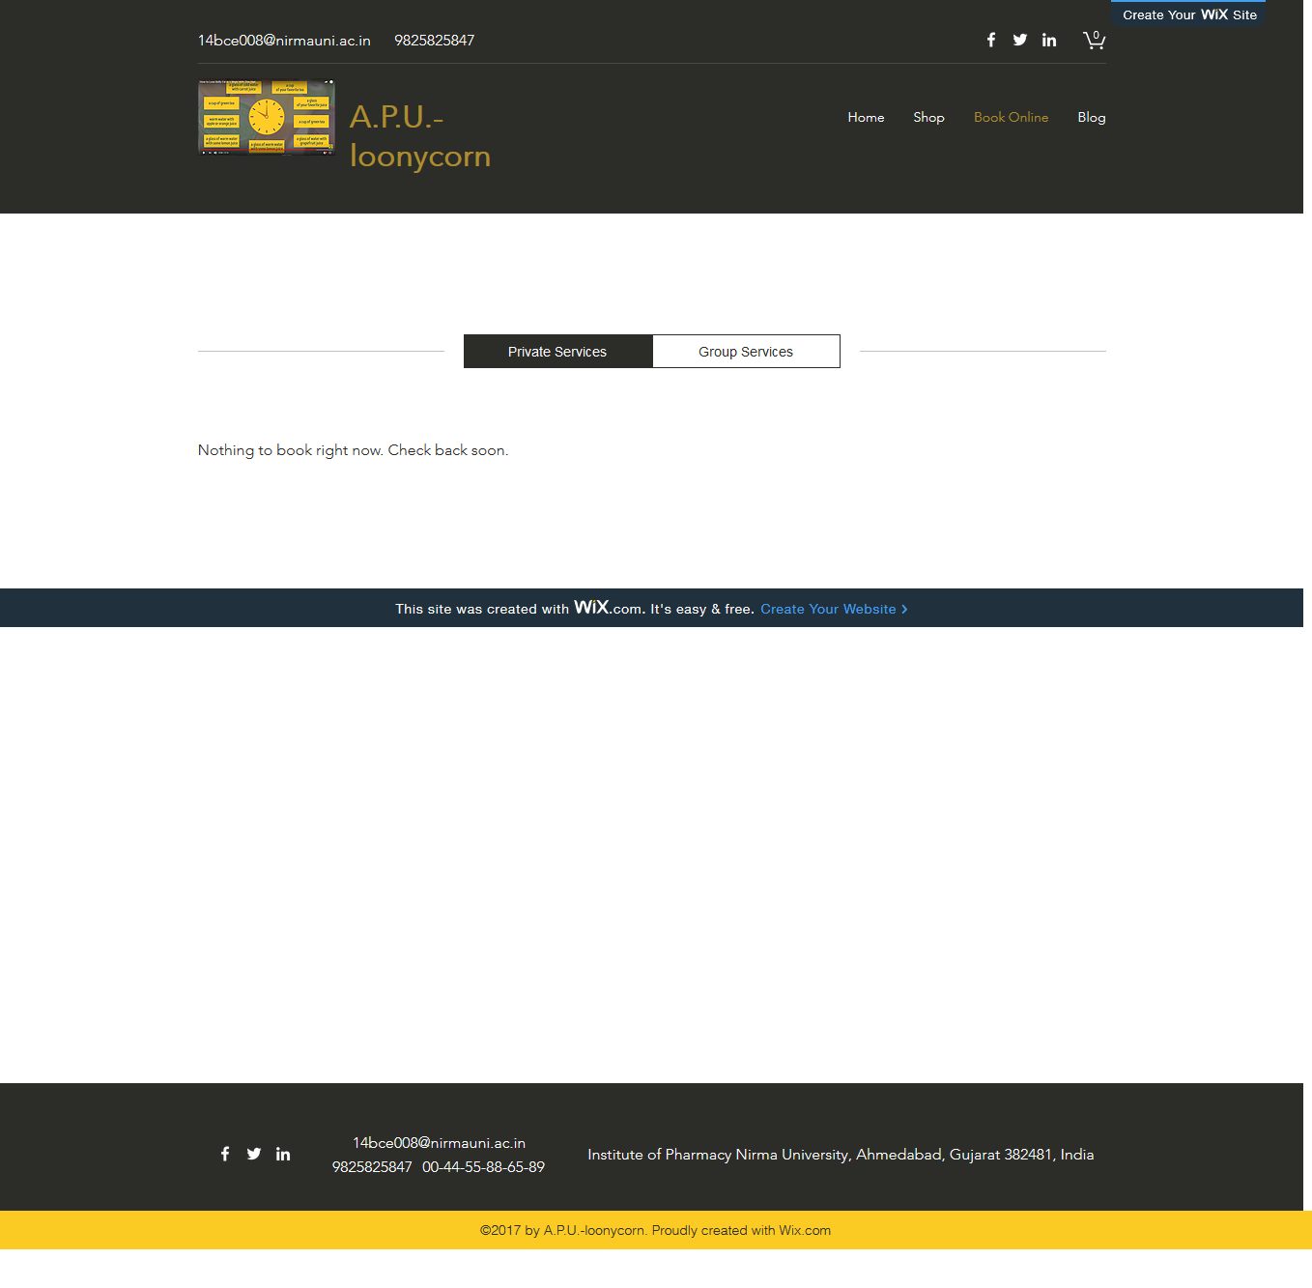

ADVANTAGES OF CMS

* It's easy for the non-technically minded.
* It allows multiple users.
* It streamlines scheduling.
* It improves site maintenance.
* Design changes are simple.
* It helps you manage content.

DIS-ADVANTAGES OF CMS

* Can require extra maintenance, backups, upgrades, security patches.
* If incorrectly used by the client it can break site.
* May have to add training to the cost of project.
* Allows for bad design of text.

CONCLUSION

This practical was helpful in developing website for the startup Loonycorn who actually somehow needed it. Dealing with contents in a simple intuitive way lead to see web-building and web-designing easy and fun. Also it provoked the need to create a website for each and every individual which in today’s world is a bare minimum .